GALS Finance Committee Agenda
Tuesday, September 3 at 11:00 am

Google Meet joining info
Video call link: https://meet.google.com/haq-kpof-wif

- Welcome, Call to Order
  - Welcome
  - Public Comment
- Business
  - Current Enrollment: 226
  - Current Working Budget: +$56,304
  - Teacher Compensation 26/27
    - If every teacher is awarded their “step” increase, that will cost GALS a total of $33K, and earn teachers an average of $1700 or a 2.5% increase from last year.
  - Teacher Compensation Beyond 2027
  - COLOTrust Investment Opportunity: How much, and for how long?
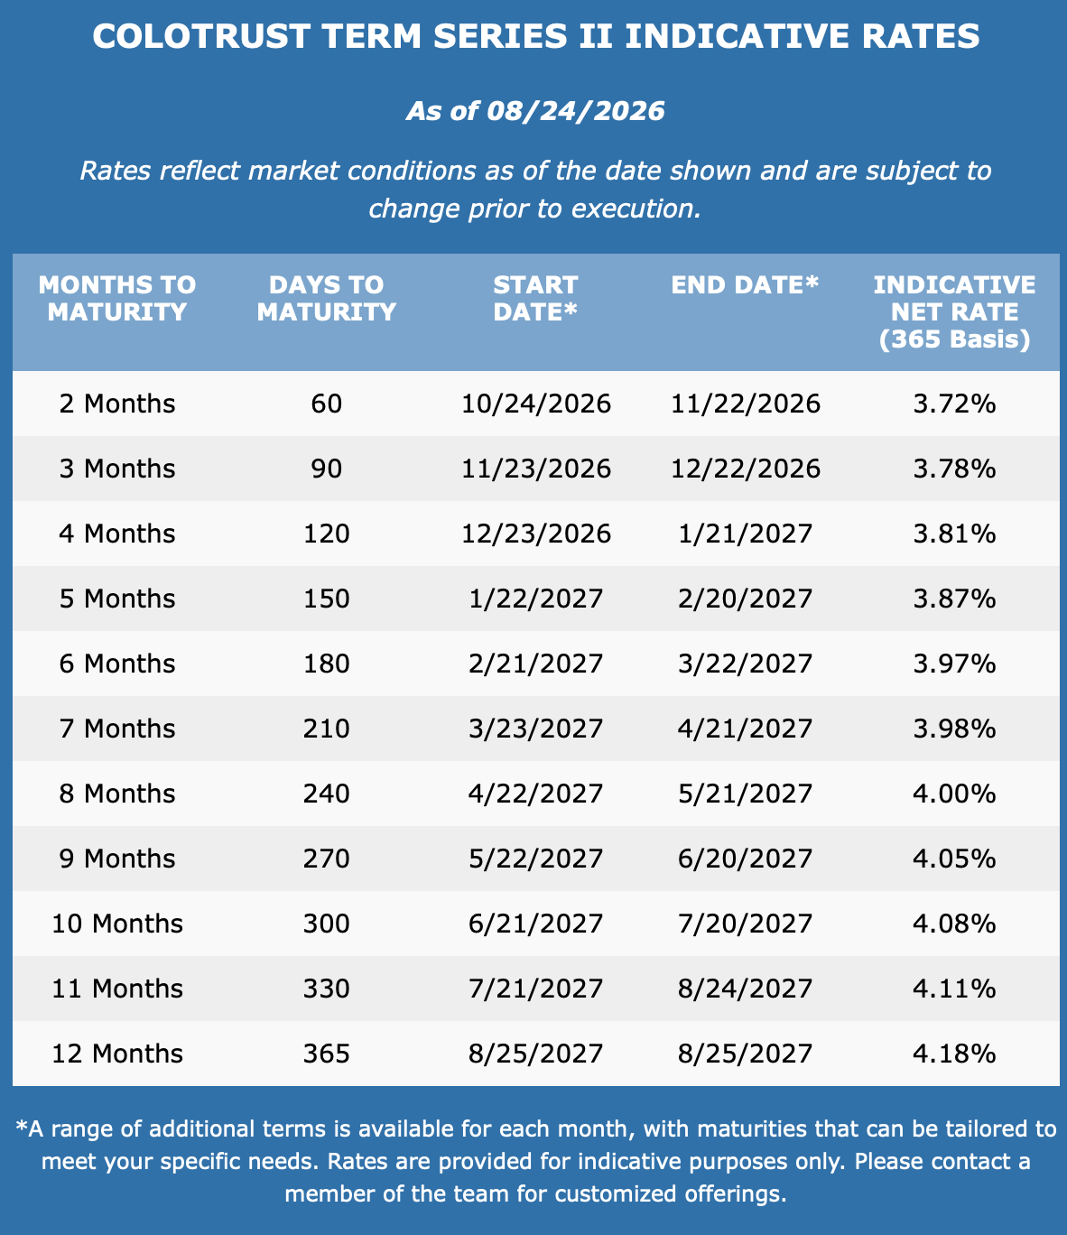
  - Capital Construction Reserves = $182,959.42
    - Should I pursue the digital sign? Estimated $40K.
  - Review Finance Committee Dashboard
  - Review Board Report

- Closing
  - Next Board Meeting: Thursday, September 10 from 6-8pm ONLINE
  - Next Finance Committee meeting: Tuesday, September 30th, 2026 at 11am online

